**Institute of Computer Technology**

**B. Tech. Computer Science and Engineering**

**Semester: III**

**Sub: Object-Oriented Programming**

**Course Code: 2CSE303**

**Practical Number:2**

**Objective:**

*To understand the concept of variable, identifier, datatypes, and program structure.*

Q.1.Problem Definition:

Q.1. Assume, you are a Java Developer in a XYZ reputed company, and your team leader assigned one task, that you have to train Java Language to your junior from scratch. So, write an appropriate program to demonstrate your “Bio-data”. [ Note: Perform this program on pre-initialize value as well as on user input value, it means you have to create one bio data on pre-initialize value, and then you have to create another program, where you have to take person information from the user, and then have to print that all information in bio-data format.]

**Code of Pre-Initialized Bio Data :**

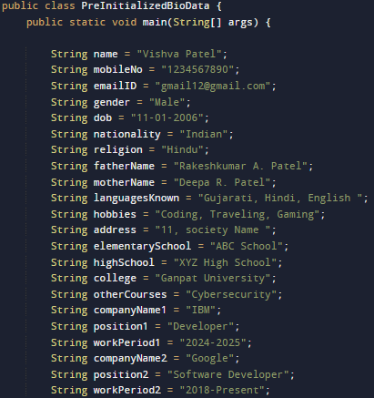

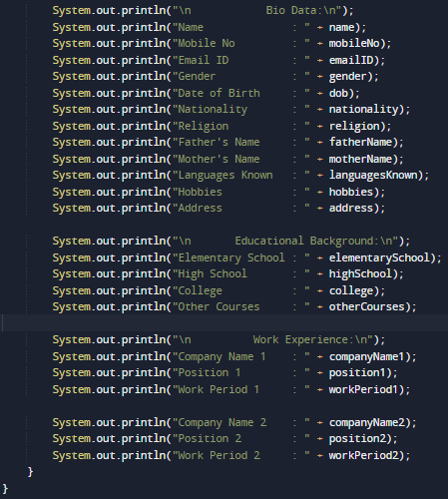

**Output :**

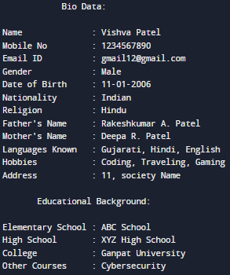

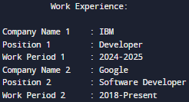

***Code of Initialized Bio Data:***

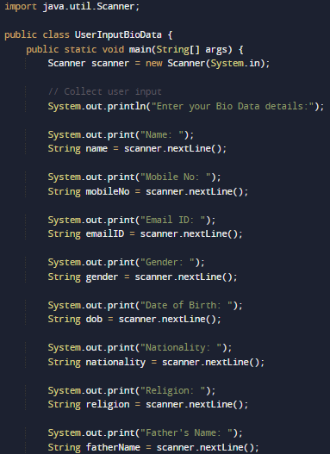

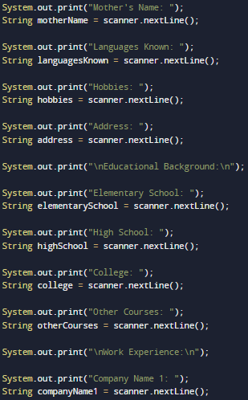

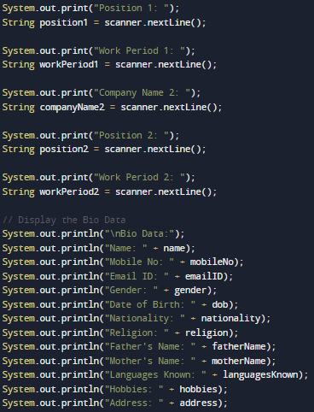

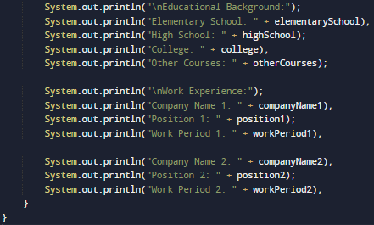

**Output:**

